Asking Questions in Academic Research
From The Craft of Research Ch. 3: “From Topics to Questions”
3.3.6: “Ask question suggested by your sources” (pg. 41)
Ask questions that build on agreement:
- If a source makes a claim you think is persuasive, ask questions that might extend its reach.
  - Ex: Elias shows that masquerade balls became popular in eighteenth-century London in response to anxieties about social mobility. Did the same anxieties cause similar developments in Venice?
- Ask questions that might support the claim with new evidence.
  - Ex: Elias supports his claim about masquerade balls with published sources. It is also supported by letters and diaries?
- Ask questions analogous to those that sources have asked about similar sources.

  - Ex: Smith analyzes costumes from an economic point of view. What would an economic analysis of masks turn up?
Now ask questions that reflect disagreement:
  - Ex: Martinez claims that carnival masks uniquely allow wearers to escape social norms. But could there be a larger pattern of all masks creating a sense of alternative forms of social or spiritual life?
3.3.7: “Evaluate your questions” (pg. 42)
Not all questions are equally good! Look for questions whose answers might make you (and, ideally, your readers) think about your topic in a new way..
AVOID questions like these:
- Their answers are settled fact that you could just look up.
  - Ex: Do the Inuit use masks in their wedding ceremonies?
- Their answers would be merely speculative…if you can’t imagine finding hard data that might settle the question, it’s a question that you can’t settle.
  - Ex: Would church services be as well attended if the congregation all wore masks?
- Their answers are dead ends. It is hard to see how an answer would help us think about any larger issue worth understanding better, so it’s a question that’s probably not worth asking.
  - Ex: How many black cats slept in the Alamo the night before the battle?
3.4: “The most significant question: SO WHAT?” (pg. 43)
Even if you are an experienced researcher, you might not be able to take [this step] until you are well into your project…Once you have a question that holds your interest, you must pose a tougher one about it: So what? Beyond your own interest in its answer, why would others think it’s a question worth asking?
Considering the so what? question early on (even if you can’t answer it just yet) forces you to look beyond your own interests to consider how your work might strike others. Think of it like this: What will be lost if you don’t answer your question? How will not answering it keep us from understanding something else better than we do?
From They Say I Say Ch. 14: “Reading for the Conversation”
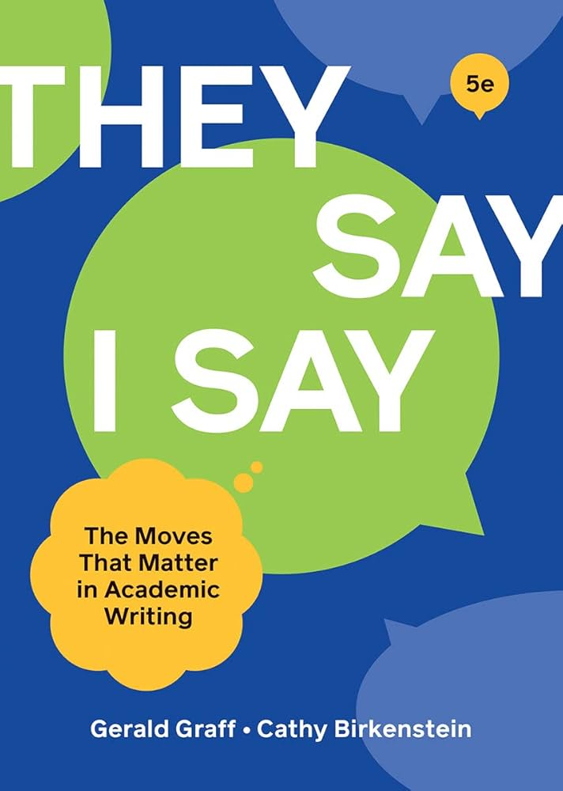
“Deciphering the Conversation”
When reading, imagine the author not as sitting alone in an empty room hunched over a desk or staring at a screen, but as sitting in a crowded coffee shop talking to and engaging with others who are making claims.
In other words, imagine an ongoing, multi sided conversation in which all participants (including the author) are trying to persuade others to agree or at least to take their positions seriously.
The trick in reading for the conversation is to figure out what views the author is responding to and what the author’s own argument is.

‘“When the ‘they say’ is about something ‘nobody has talked about’”
Sometimes writers build their arguments by responding to a lack of discussion.
These writers build their case not by playing off views that can be identified but by pointing to something others have overlooked. As the writing theorists John M. Swales and Christine B. Feak point out, one effective way to “create a research space” and “establish a niche” in the academic world is “by indicating a gap in…previous research.”
In such cases, a writer may be responding to scientists, for example, who have overlooked an obscure plant that offers insights into global warming or to literary critics who have been so busy focusing on the lead character in a play that they have overlooked something important about the minor characters.
From They Say I Say Ch. 15: “Research as Conversation”
Templates to Develop a Good [Further] Research Questions
A good research question focuses on a debate or conversation that both narrows down your sources and helps you integrate or synthesize those sources under a common umbrella issue:
- Why did X happen? Was it, as _ argues, because of _, or as _ contends, because of _?
- What should we do about X? Should we _, as _ urges, or _, as _ argues?
- Is it as harmful as _ insists, or does it have benefits, as _ claims?
- Is it true, as some assert, that _?
- What is the relationship between _ and _? Is it X, as most assume, or could it be Y, as _ suggests?
“Let one good source lead to another”
How do you find a question or issue that different people–you and your sources–disagree about?
By looking in your sources themselves. Sources frequently response to other sources, either to confirm what those other sources are saying, contradict it, or some combination of both, as in:
- X is far too pessimistic in her predication that _.
- Authors X and Y focus on the wrong issue. The issue is not _, but _.
- I agree with X in her critique of the view that _, but _.
In such ways, sources are connected together in an intertextual network of conversation that the best researchers are always alert for.

